## Using Visio Shape Data (QRC)

## Introduction

This QRC provides the guidance on using **Shape Data** in Visio. Shape Data displays the architecture information loaded from Excel workbooks into a Shape's properties.

## Features covered within this QRC include instructions on how to:

* Turn On/Off Displaying Shape Data and/or External Data Panels
* Refresh Shape Data
* Resolve “Refresh” or "Refresh All" generates an error
* Identify Shapes in Document Stencil
* Easily find associations – Shape to Data
* Easily find associations – Data to Shape
* Select which Shape Data attributes to include during a Link Data to Shape operation
* Link Single Data Row to Single Shape by Using Drag & Drop
* Link Multiple Data Row to Single Shape by Using Drag & Drop
* Link Single or Multiple Data Rows to Single or Multiple Shapes by Using Drag & Drop
* Link Data to Selected Shape
* Unlink Data from Shape

NOTE: This QRC uses the Conceptual Architecture Diagram to demonstrate the features, these instruction are applicable to all Visio artifact templates.

## Regarding These Instructions for Visio Linked Data Shapes

The EMAF templates simplify an architect's work by allowing them to manage the data associated to each architecture element (object) within Excel, and then loading this data by merely selected the correct architecture shape and Excel row and then dragging the row on to the canvas. All templates are created to have pre-loaded the necessary Excel tabs from workbooks located in the same directory as the diagram.

Benefits for using this Visio feature includes:

* Allows information from architecture workshops or design sessions to be quickly captured and managed in Excel - a tool all architects are familiar with
* Allows architecture designs to be quickly and easily created into rich architecture Visio diagrams
* Allows the information contained within Excel and/or Visio to be uploaded into DBM or ARIS, thus saving the architect hours or days of effort of rekeying this information
* Sets the foundation for future bi-directional flow of information between DBM and Excel to allow architects work offline or to use for future workshops or design sessions

## Instructions to Turn On/Off Displaying Shape Data and/or External Data Panels

On create from template, the display of **Shape Data Window** and **External Data Window** can be turned on/off.

On **Data** menu, **check** boxes for "Shape Data Window" and "External Data Window" to turn **On** display of these window panels. **Uncheck** these boxes to turn **off** display of these window panels.

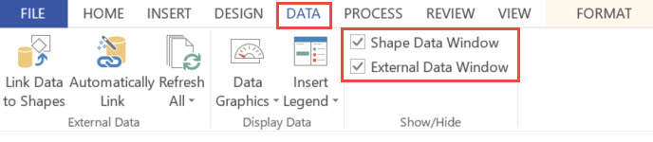

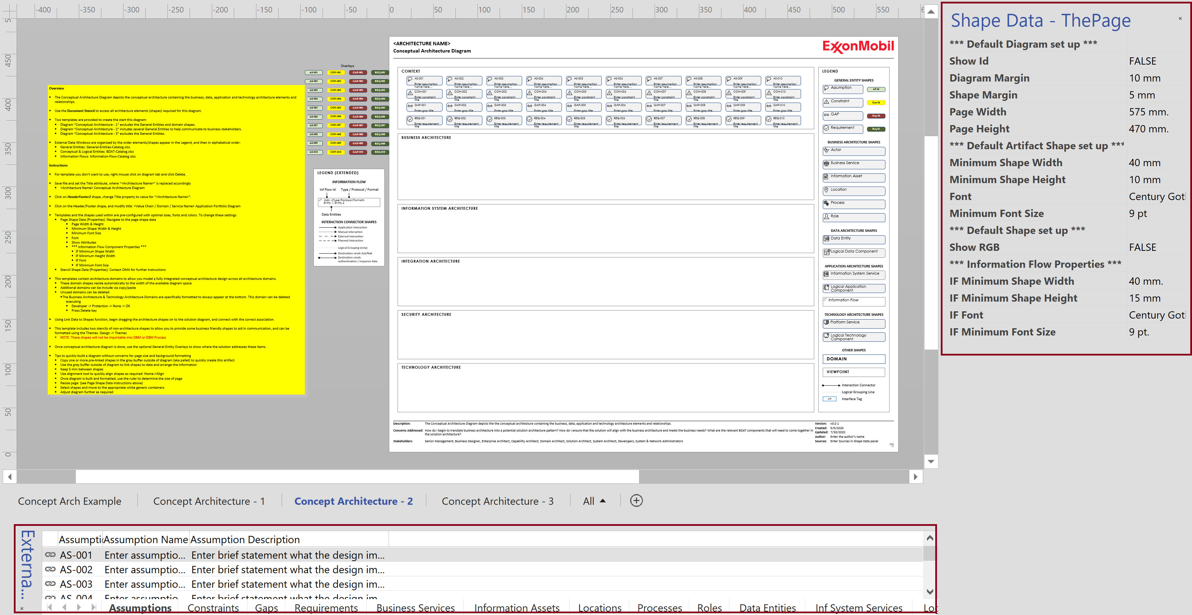

## Instructions to Refresh Shape Data

Visio provides two options to refresh shape data:

1. Refresh All – refreshes all linked external data windows
2. Refresh – refreshes the current external data window

**REFRESH ALL** - On **External Data** panel ensure the correct data sheet is selected. Select **Refresh All** option on **Data** menu to refresh all template shapes with data from selected spreadsheet.

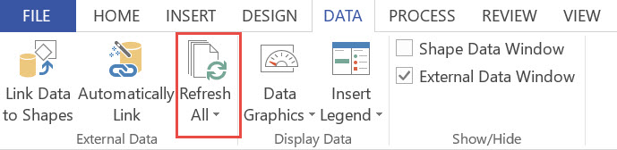

**REFRESH DATA** - On **External Data** panel select the **Data Row** that needs to be populated on to shape on template. Right click **Refresh Data.** Populates the data from selected row to associated shape on template.

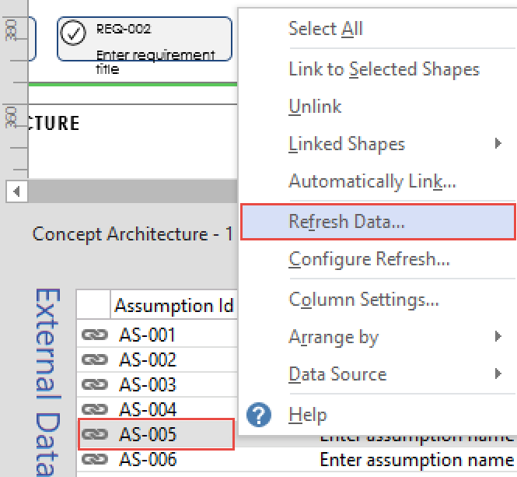

## Instructions to Resolve “Refresh” or "Refresh All" generates an error

Visio 2013 can experience a random error where Visio loses track of where the Excel workbook is located. This QRC will allow an architect to quickly re-establish the data-link between the Visio diagram and tab in an Excel workbook.

In this QRC, the "Business Capability Assessment Workbook.xlsx", tab "Data Export (Questionnaire)" is used, although these instructions can be used on any Visio data-linked Excel workbook tab.

1. On **External Data** panel ensure the correct data sheet is selected. Select **Refresh All** option on **Data** menu to refresh all template shapes with data from selected spreadsheet.



1. **Unable to connect to the data** error displays as below. **To fix this error** - Make a note of **Sheet Name** and select **Skip Refresh** option

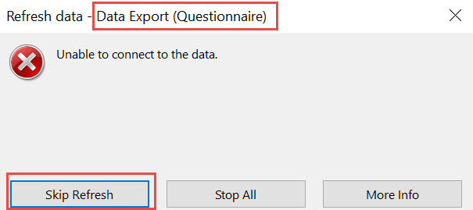

1. Select **Configure Refresh**… option

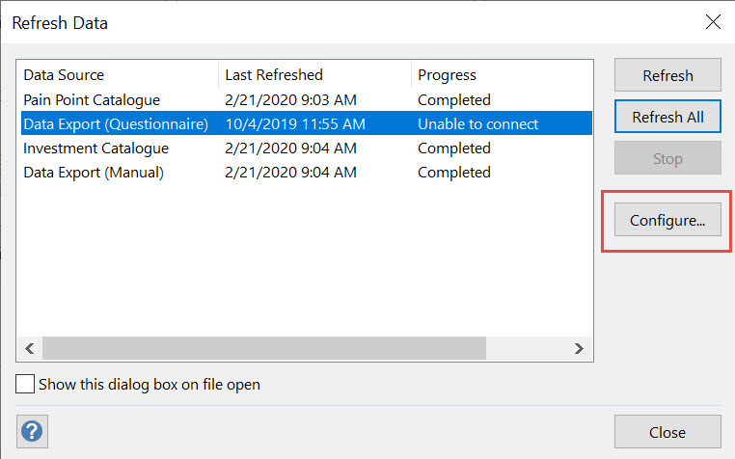

1. Select **Change Data Source...** button

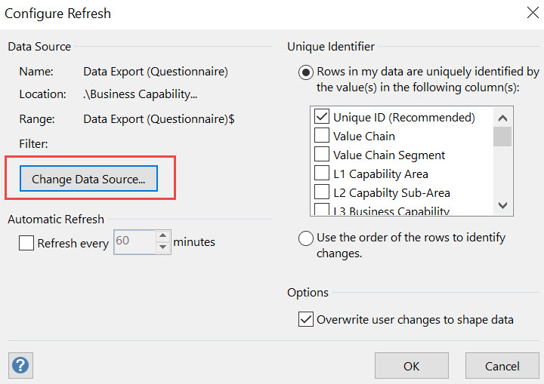

1. Select **Microsoft Excel Workbook** option for data to be used and click **Next** and then **Browse** button

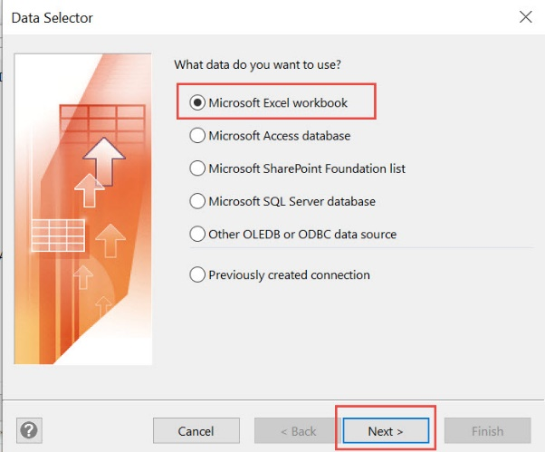

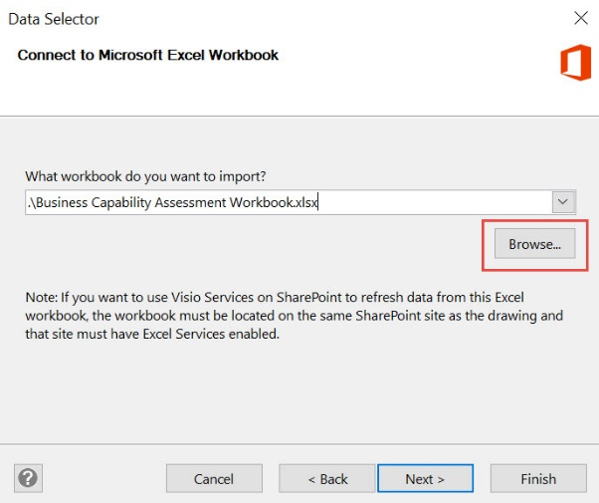

1. On File Explorer, navigate to your **Project** folder in SharePoint or local drive and select the **associated excel workbook:**
   1. If Local Folder, navigate to: **C:\Users\<your-network-id>\LocalData\My Projects\project-name**

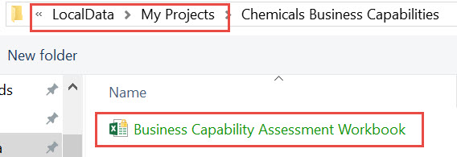

* + - The excel workbook gets populated with **complete path** as **highlighted**

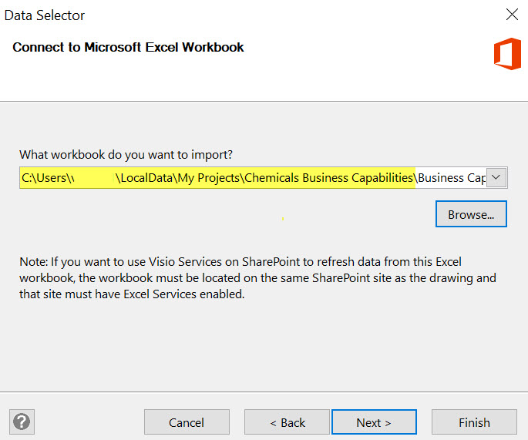

* + - Remove **complete path** and replace with '.'

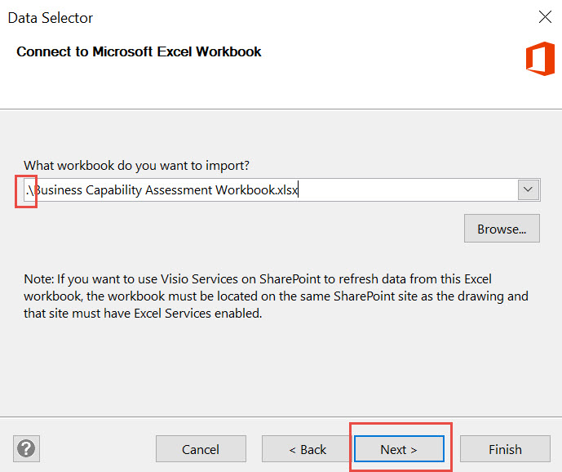

* 1. If SharePoint, copy the following URL into Navigation bar: **https://ishareteam4.na.xom.com/sites/Architect/Architecture Repository**
     + Navigate to your working folder: **Working library/<value-chain>/<capability>/<architecture-folder>**

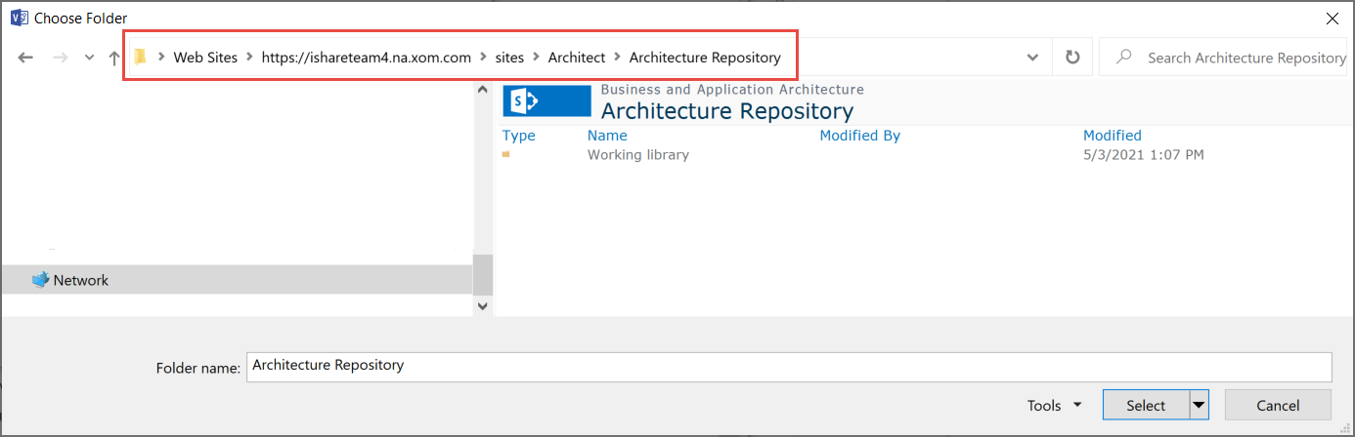

* + - Select the appropriate EMAF Excel catalog and click the **Open** button.

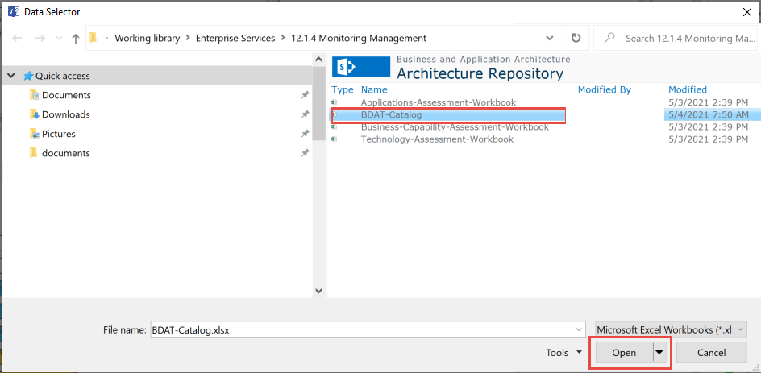

1. Select worksheet from drop-down **SheetName$** and click **Next**

NOTE - SheetName ending with '$' is the table that contains data

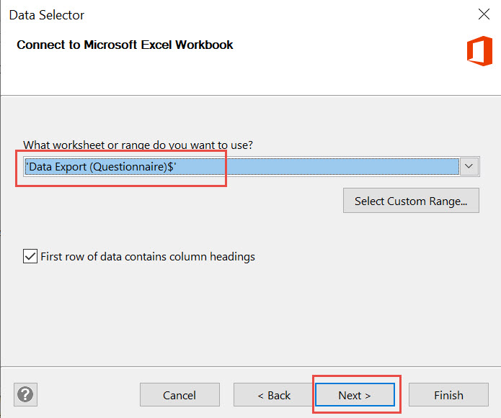

1. On **Connect Data** window, leave *Default* values and select **Next**

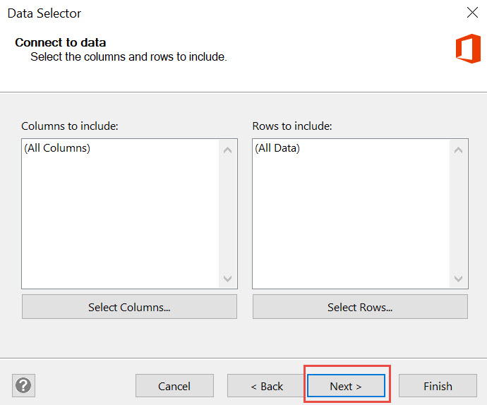

1. Data Import completes successfully. Click **Finish** button

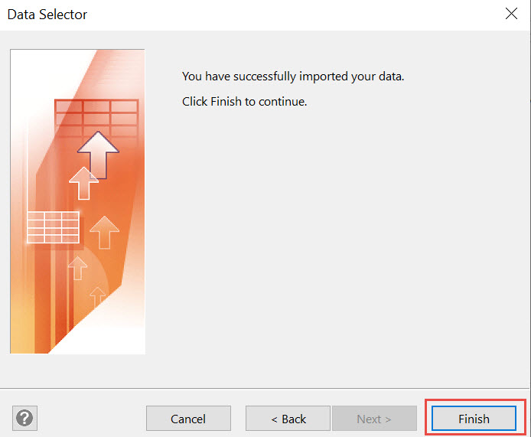

1. Accept **Default** values and click **OK** button

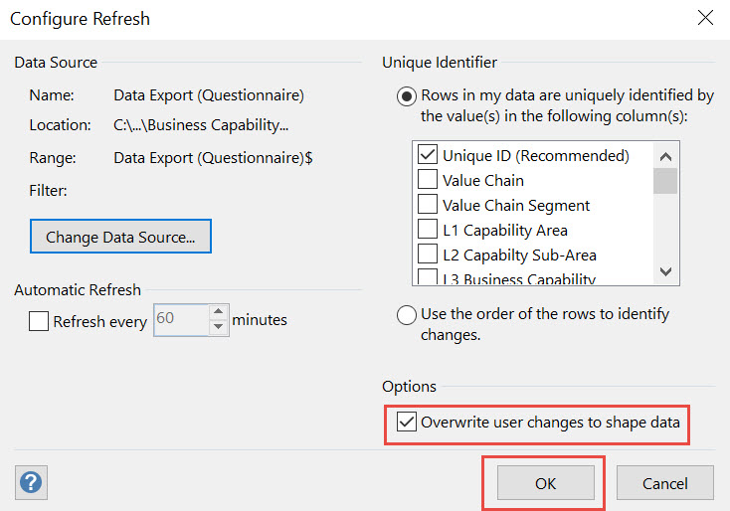

1. On **Refresh Data** window, select **source** that is **Unable to Connect** and click **Refresh**

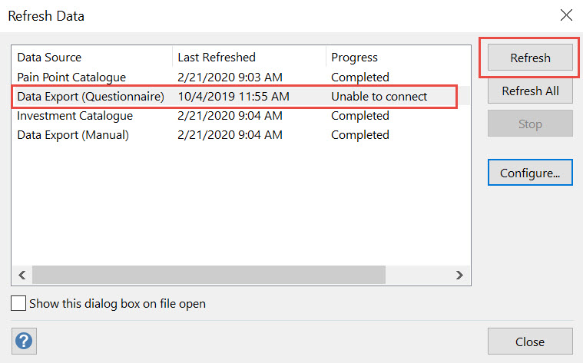

1. Note refresh status change to **Completed**

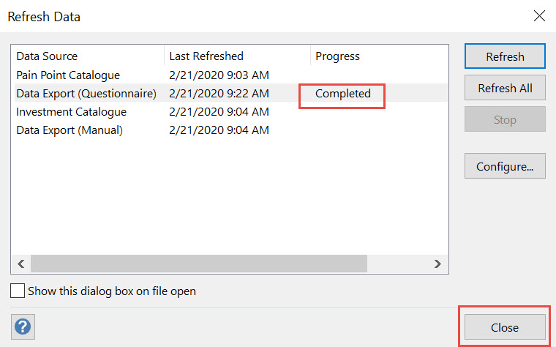

## Instructions to Identify Shapes in Document Stencil

1. On **Shapes Panel** (Left Panel), select **Document Stencil** to display all Shapes used on template

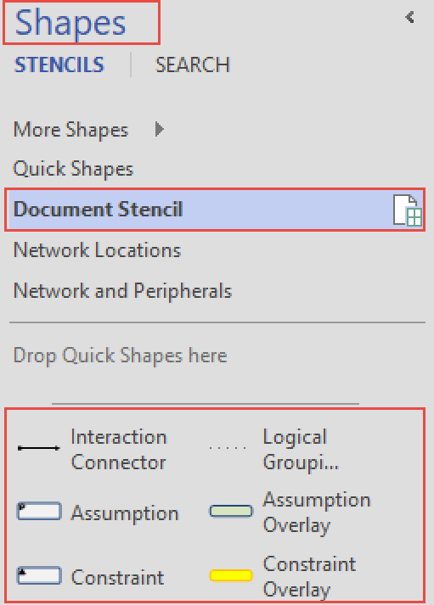

1. Hover-over Shape object in Shapes Panel to display **Shape Description**

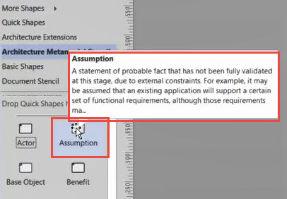

## Instructions to easily find associations – Shape to Data

1. Select a **Shape** on template. **Right-click -> Data -> Show Linked Row**

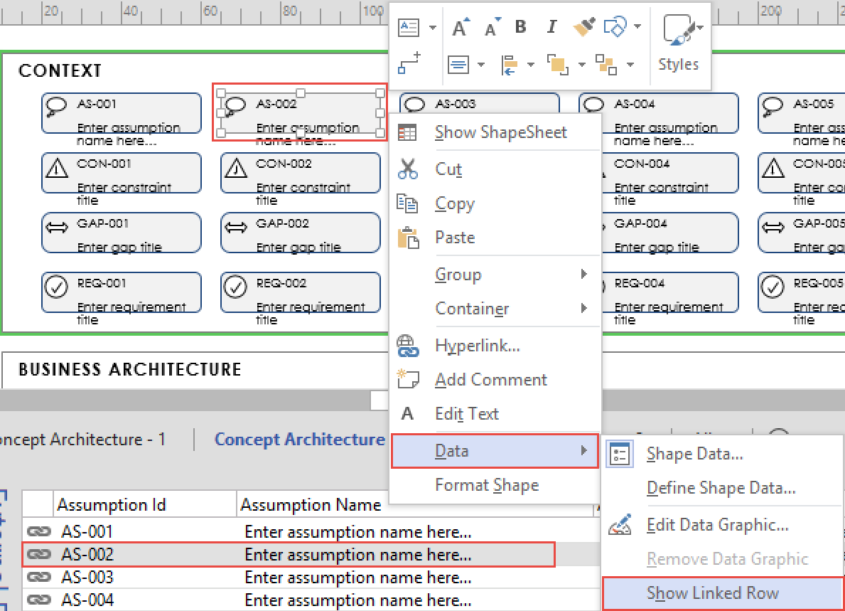

1. On **External Data** Panel, linked/associated **Data Row** is **highlighted**

## Instructions to Easily Find Associations – Data to Shape

1. Select a **Data Row** on External Data panel. **Right-click -> Linked Shapes -> Shape name**

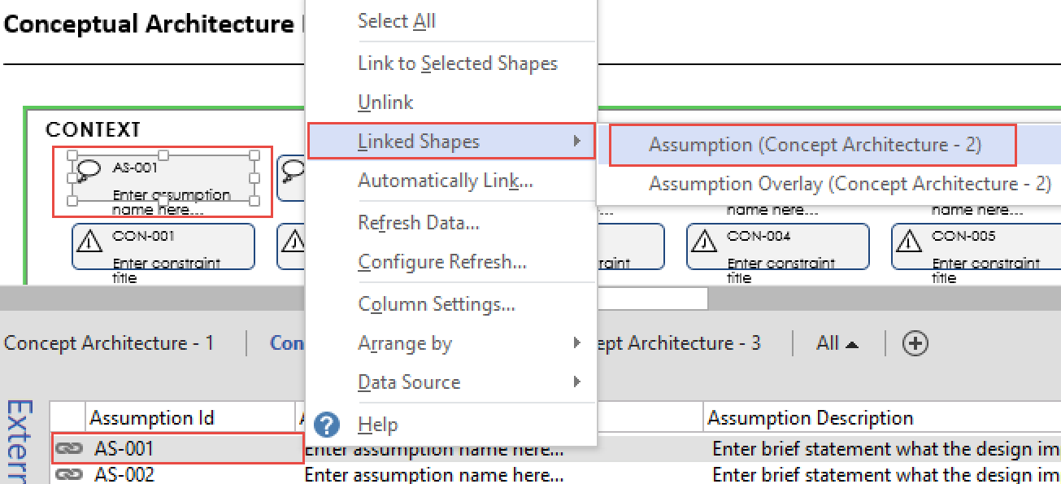

In this example, the same linked shape exists on two different diagrams. Whichever one you select, the correct diagram will be displayed.

1. On **Template Diagram**, linked/associated **Shape(s)** is **highlighted**

## Instructions to Select Which Shape Data Attributes to Include During a Link Data to Shape Operation

Note: By default, all Visio artifacts templates are pre-configured to include standard supported attributes. This instruction is only necessary if you have added custom attributes to the Excel Files

1. Select a **Data Row** on External Data panel. **Right-click -> Column Settings**

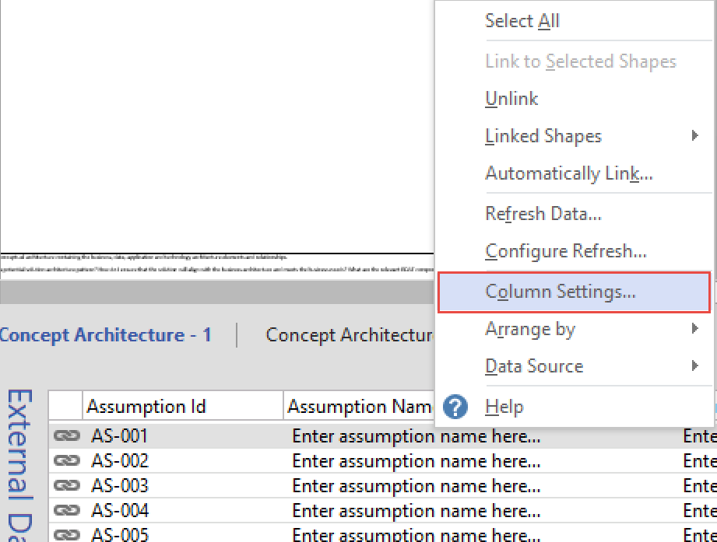

1. **Uncheck** the boxes for columns that are not to be displayed. Only columns with boxes checked will be displayed

**All previously linked shapes will be updates with the attribute changes. All newly linked shapes will also include these new attributes.**

## Instructions to Link Single Data Row to Single Shape by Using Drag & Drop

1. Within the Document Stencil, select the shape you want to include in model. For example, Business Service

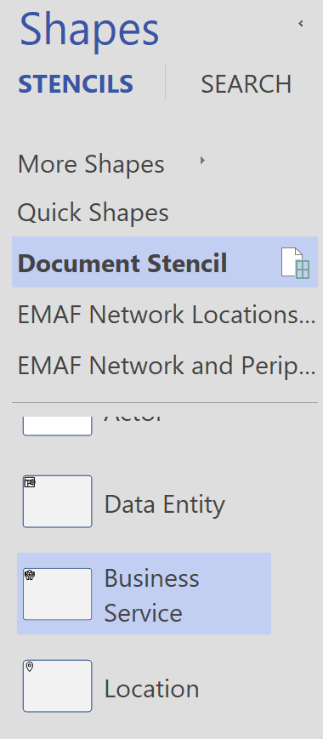

1. Navigate to the associated External Data Tab for this shape. For example, Business Services. Find and click on the record you want to include in model.

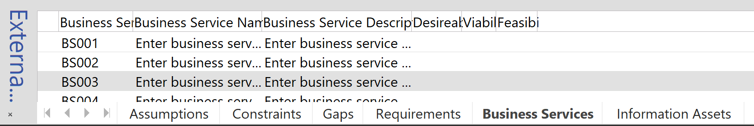

1. Click on the record and drag the mouse into the gray area outside of diagram. Once the mouse is released, the data record is bound to the shape.

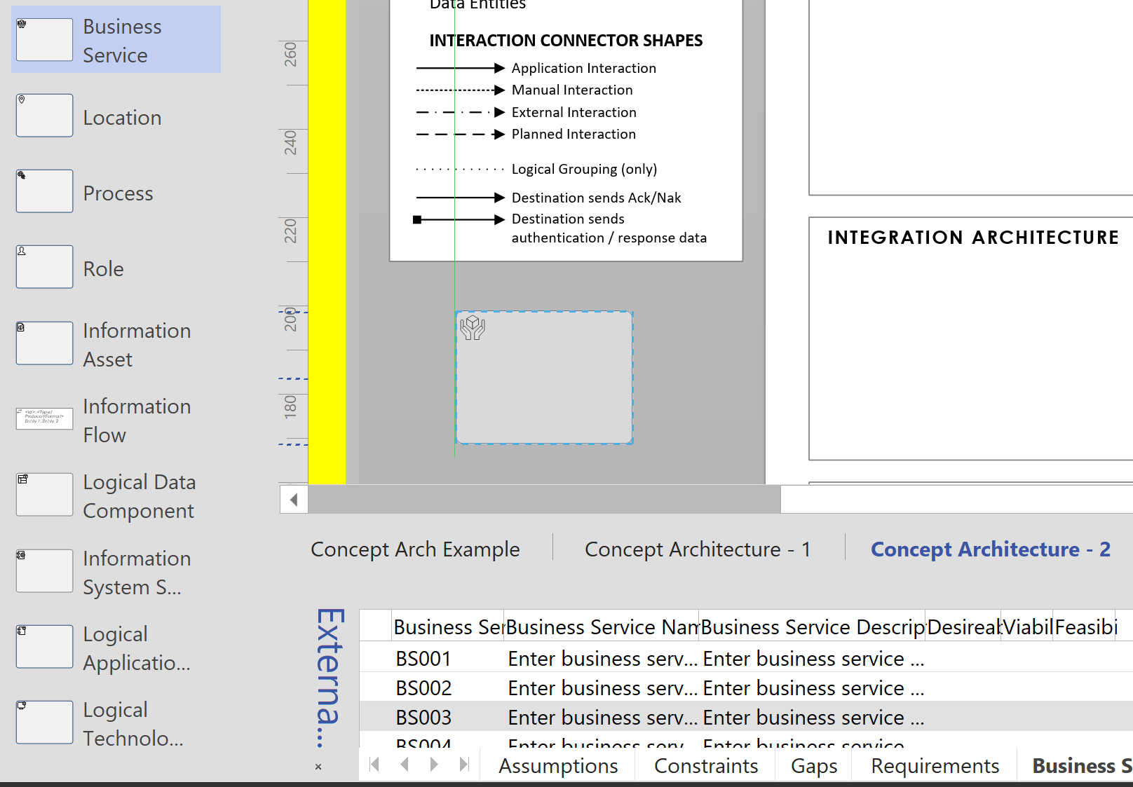 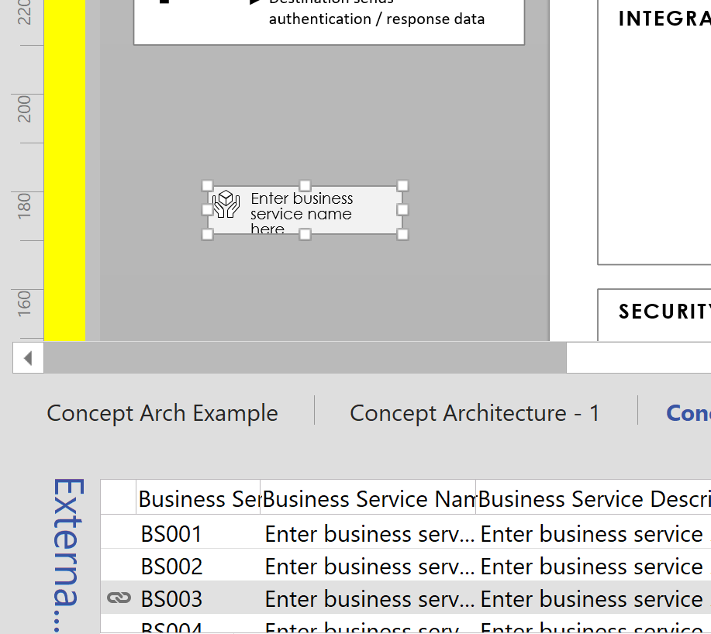

1. Move the shape on to the drawing.

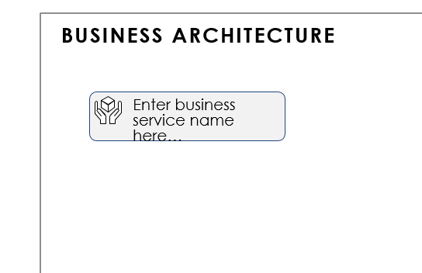

## Instructions to Link Multiple Data Row to Single Shape by Using Drag & Drop

1. Within the Document Stencil, select the shape you want to include in model. For example, Business Service



1. Navigate to the associated External Data Tab for this shape. For example, Business Services. Find and click on the record you want to include in model.

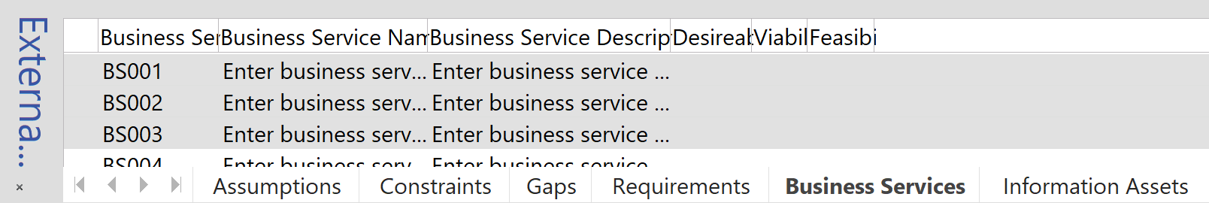

1. Click on the record and drag the mouse into the gray area outside of diagram. Once the mouse is released, the data record is bound to the shape.

 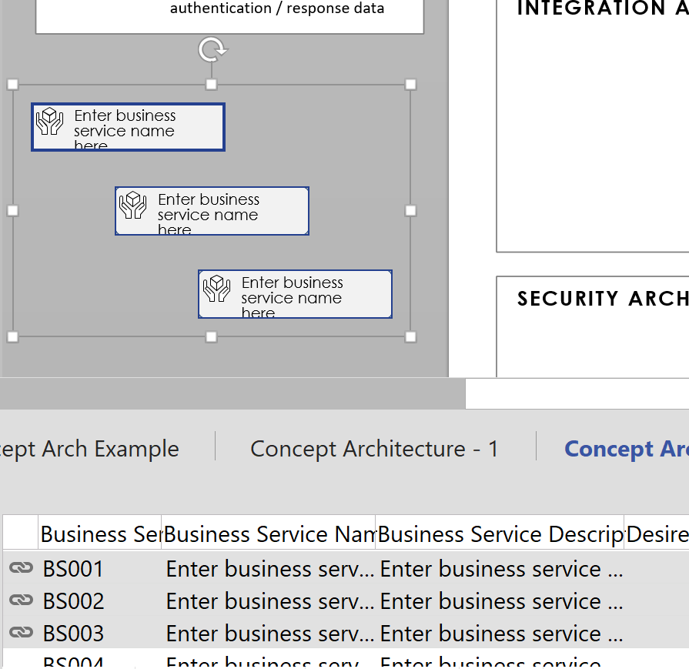

1. Move the shape on to the drawing.

## 

## Instructions to Link Single or Multiple Data Rows to Single or Multiple Shapes by Using Drag & Drop

1. Within the Document Stencil, select the shape you want to include in model. For example, Assumption and Assumption Overlay

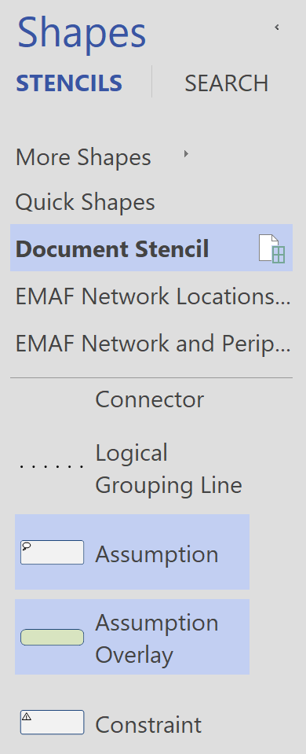

1. Navigate to the associated External Data Tab for this shape. For example, Assumptions. Find and click on the record you want to include in model.

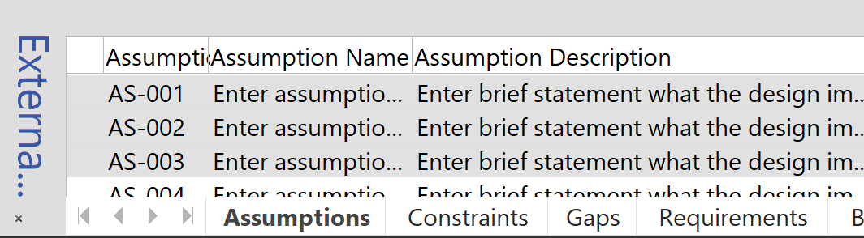

1. Click on the record and drag the mouse into the gray area outside of diagram. Once the mouse is released, the data record is bound to the shape.

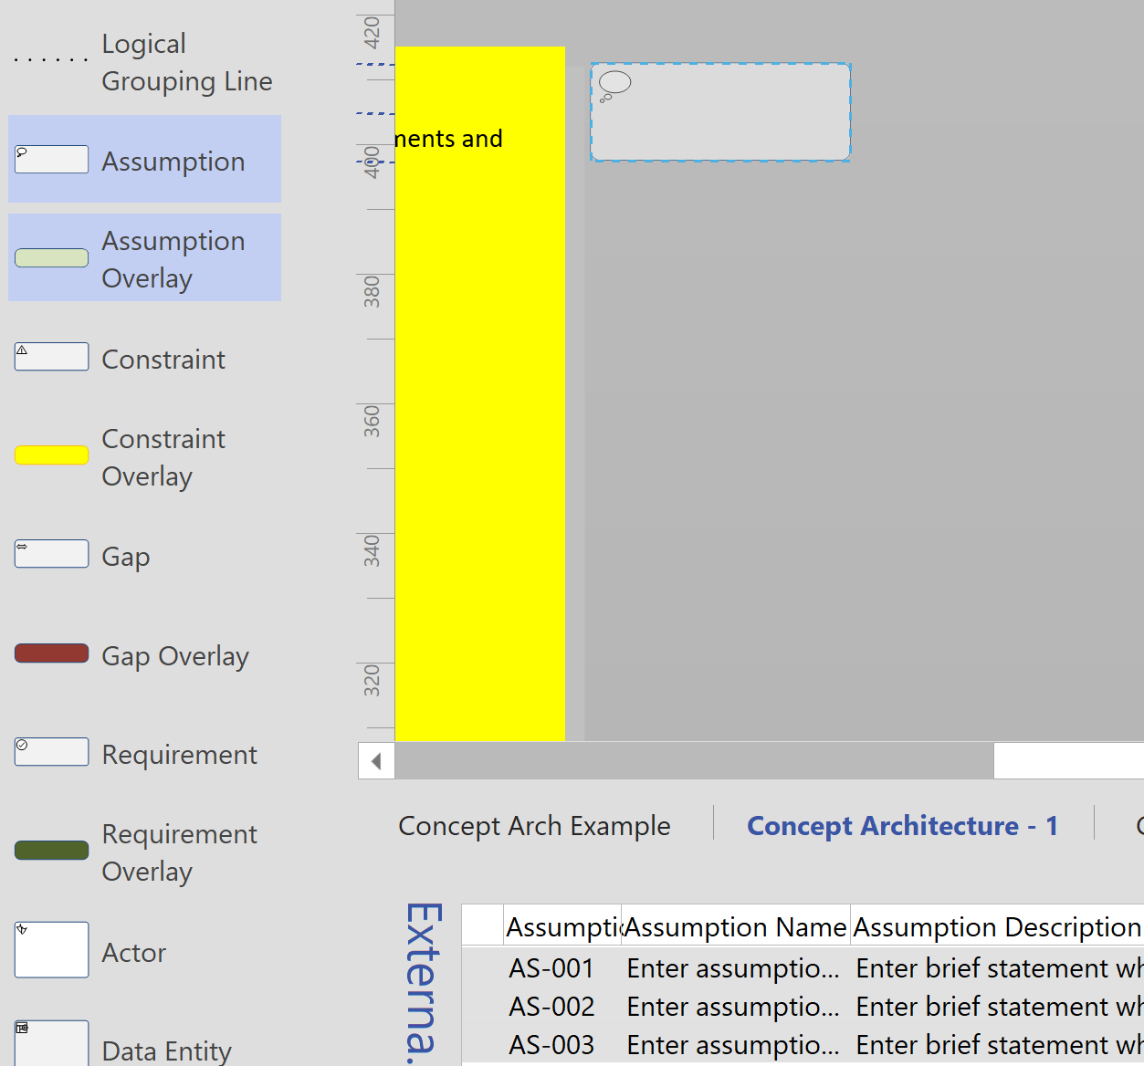 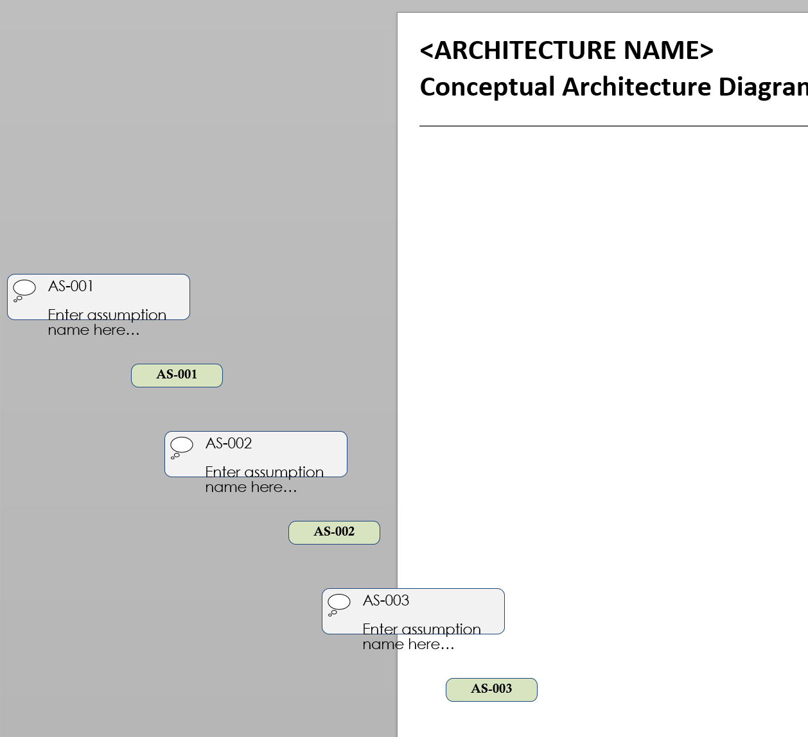

1. Move the shape on to the drawing.

## 

## Instructions to Link Data to Selected Shape

1. First select a **Shape on Template diagram**, then select a **Data Row** on External Data panel that is not linked (**Right-click -> Link to Selected Shapes**)

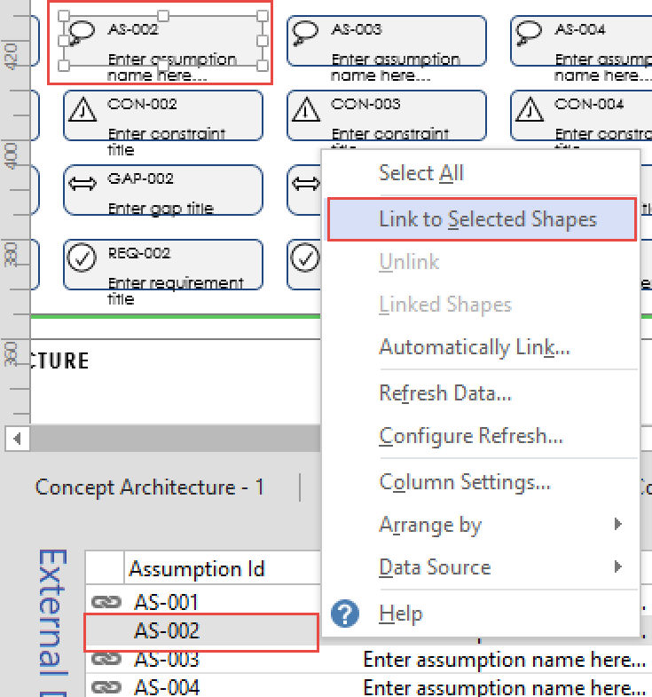

1. The selected data row gets **linked** to selected Shape

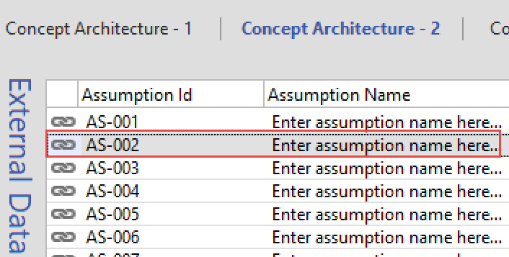

## Instructions to Unlink Data from Shape

1. Select a **Data Row** on External Data panel that is linked. **Right-click -> Unlink**

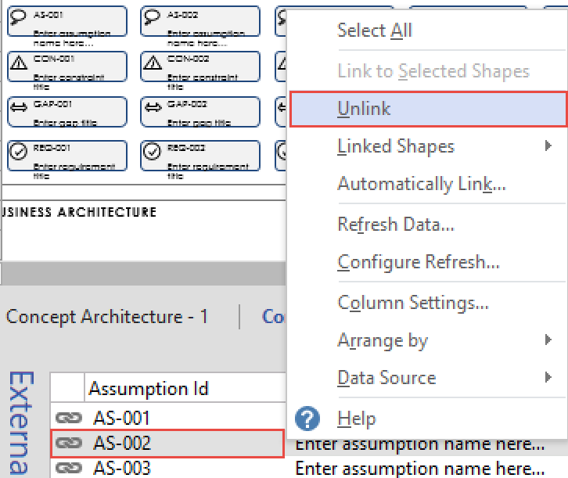

1. Selected data row gets **unlinked**

